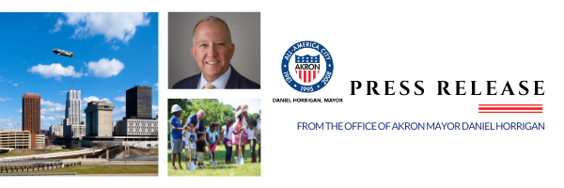

For Immediate Release

Contact: City of Akron Press Office

Press@akronohio.gov or 330-375-2754

City of Akron and John S. and James L. Knight Foundation Announce New Funding for Lock 3 Vision Plan

Akron, Ohio, March 1, 2022 — Today, March 1, 2022, at an event at the Richard Howe House, City of Akron Mayor Dan Horrigan announced a $3.5M contribution from the City’s American Rescue Plan Act (ARPA) funding for the implementation of the Lock 3 Vision Plan. Additionally, John S. and James L. Knight Foundation Akron Program Director, Kyle Kutuchief announced that Knight Foundation will match the City’s funding with their own $3.5 million investment. With these additional commitments, the final design for Lock 3 Park will be completed, with a proposed groundbreaking in the fall of 2022.

The Lock 3 Vision Plan is a key component of the resident-led Akron Civic Commons 2.0 project that plans to build on the success of Lock 3 Park as a successful event, concert and festival public space and develop a year-round park that is a destination for residents, guests, hikers and bicyclists along the Ohio & Erie Canal Towpath Trail. Some of the elements that residents have identified as priorities for Lock 3 moving forward are shaded seating, landscaped gardens, artwork, skating areas and a world-class performance pavilion. You can see up to date design renderings for the future of Lock 3 here.

The City of Akron and the Knight Foundation were joined at the event by various community partners including Akron City Council President Margo Sommerville and other members of City Council, President and CEO of Ohio & Erie Canalway Coalition (OECC) Dan Rice and others from OECC, Akron Civic Commons Donor Committee Co-Chairs Bill and Becky Considine and others from Akron Civic Commons, as well as representatives from Akron Children’s Hospital, Akron Children’s Museum, Akron Civic Theatre, Downtown Akron Partnership, Summit County government, and more.

"All residents, regardless of their income, race, education, or experience deserve outstanding parks and open spaces for recreation and relaxation," said Akron Mayor Dan Horrigan. "We are very proud to partner with the City of Akron residents, Knight Foundation, Akron Civic Commons, Ohio & Erie Canalway Coalition, and all of our funders and partners on this transformational project at Lock 3, right here in the heart of our community."

The City’s $3.5M contribution is in addition to the previous contribution of $1.5M and brings the total City of Akron commitment to $5 million. Knight Foundation’s $3.5M grant award is in addition to the previous contribution of $2M and brings the total Knight commitment to $5.5M.

“Locks 2, 3 and 4 are Akron’s Central Park and have been a priority for Reimaging the Civic Commons in Akron since 2017,” said Kyle Kutuchief, Knight Foundation Program Director in Akron. “We at Knight believe the transformation of Lock 3 Park will strengthen it as a special event venue and an everyday park to connect people of all backgrounds, cultivate trust and create a more resilient and engaged Akron.”

The total projected cost of the Lock 3 Vision Plan is $10M and includes funding from the City of Akron, John S. and James L. Knight Foundation, Summit County Government, Ohio & Erie Canalway, and individual donors. Akron Civic Commons 2.0 is coordinated by Ohio & Erie Canalway Coalition, in partnership with the City of Akron, and they serve as the fiscal agent and project manager for Lock 3 Vision Plan.

President and CEO of Ohio & Erie Canalway Coalition Dan Rice added, "With these generous contributions, we are moving from dreams to reality. We are building on the history of Lock 3 Park as a successful event space to develop a '365-day' park that is a destination for both residents and visitors alike. Most importantly, today, we are honoring our commitment to the City of Akron residents to co-create, co-design and co-steward outstanding parks, trails, and open spaces which center neighborhood residents at the core of our work.”

The fundraising campaign for Akron Civic Commons 2.0 continues with the goal of raising additional funding for Phase II, Locks 2 & 4, Play Loop in downtown Akron and an endowment for operations and maintenance. For more information about donation opportunities and Akron Civic Commons 2.0, please contact Dan Rice, at drice@ohioeriecanal.org or (330) 374-5657.

##

